Account Lookups

The fields shown below may be used to help you quickly find the Account you are seeking, and are available throughout the Utility Billing application:

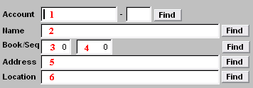
Select ONE of the following fields:

- Account: Enter partial account number and click “Find”. The “Lookup” window will appear. See page 2 for a view of the ‘Lookup” window and directions for its use.

- Name: Enter partial name and click “Find”. The “Lookup” window will appear. See page 2 for a view of the ‘Lookup” window and directions for its use

- Book/Seq: Enter a book number (3), and sequence number (4) and click “Find”. The “Lookup” window will appear. See page 2 for a view of the “Lookup” window and directions for its use.

- Address: Enter partial address (physical location, NOT mailing address) and click “Find”. The “Lookup” window will appear. See page 2 for a view of the ‘Lookup” window and directions for its use.

- Location: Enter partial location (physical location, NOT mailing address) and click “Find”. The “Lookup” window will appear. See page 2 for a view of the “Lookup” window and directions for its use.
The “Lookup” Window
The Lookup window will appear when you have entered partial information (anything other than a full, valid and unique piece of account information) as described above and clicked “Find.” The order in which this information appears will be based upon the field selected above.

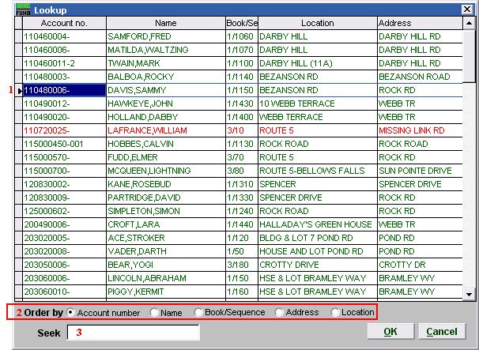

- You may click directly on the account you are seeking and click “OK” to select it, OR you may use your arrow keys to move the highlighter to the account you are seeking, and click “OK” (or hit Enter) to select it.

- Order: You may choose the order in which information will appear by clicking on the circle next to: “Account number” to sort by Account number, “Name” to sort alphabetically by last name, “Book/Sequence” to sort by book order and sequence number, “Address” to sort by Physical Address, “Location” to sort by Location.

- Seek: Enter partial account information associated with “Order” selected (see 2.), and the highlighter (1) will move to the most similar account. Click “OK” to select.

Click “Cancel” to return to the previous screen.

